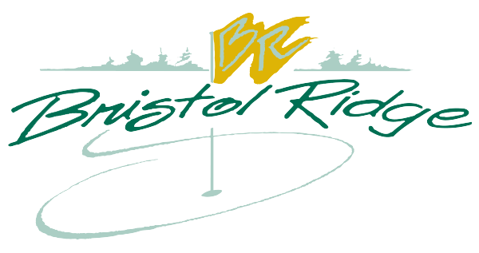
Registration Form For BR Junior Golf

Players Name: _______________________ Circle Group: Beginner Intermediate Advanced
Phone Number: ________________ Age, Gender, and Grade of Player: ____ M F ___
Address: ___________________________ City/State: ________________
Father / Guardian: ____________________ Phone: ______________ Email: ___________
Mother/ Guardian: ___________________ Phone: ______________ Email: ___________
In Case of Emergency, Call: _____________________________________ Phone: __________
I give my permission for my son/daughter ________________________ to participate in the Bristol Ridge Junior Golf Program.
WAIVER OF RESPONSIBILITY, EMERGENCY TREATMENT AUTHORIZATION, AND HEALTH CARE COVERAGE.
I waive and release forever any and all rights and claims I may have against Bristol Ridge Golf Course, as well as the organizers and volunteers of the junior program, against any claim on behalf of the participant.
I attest and verify that my son/daughter is physically fit for this activity. I fully understand the risks inherent in this activity. My son/daughter is voluntarily participating in this activity and agrees to conform to the rules/instructions of Bristol Ridge Golf Course and the program’s instructors.
My son/daughter also agrees to follow the rules and regulations provided by the junior program and Bristol Ridge Golf Course. Privileges can be modified or withdrawn if not followed.
If emergency treatment is required, I give permission for program instructors to use their judgment in calling for emergency services or sending my child to receive medical care (parents/guardians will be contacted as soon as possible). If I cannot be reached, I grant my permission for any necessary emergency first aid or medical treatment.

Parents or Guardian Signature ______________________________ Date ________________________

